Student Name: Hannah Ashna Jacob

Game Name: Wizard’s Curse

Brief description: It seems that the warlock you spoke to double-crossed you and you are now trapped in his dungeon! You will need to navigate a way out all while trying to keep your sanity intact and your health bar looking healthy. With monsters lurking around almost every corner, will you be the first to survive this dungeon of horrors?

Description of Game Play
When the player first hits play, they are immediately transported into a dungeon by some peculiar portal. It appears that they are stuck in a dungeon and must find their way out by moving between rooms to hopefully discover the right pathway to the exit. However, what they do not know is that the dungeon map is randomly generated each time and so the path out is seldom the same. Behind each door to a new room is the possibility of different enemy and loot combinations. When the player begins their adventure, they will first pick up the starting weapon (a sword) and consumables (two healing potions) provided to them. They will then begin to navigate their way around the dungeon. Upon finding an enemy, a battle sequence is initiated, and they must defeat the enemy before being allowed to move between rooms again. Once the enemy is defeated the player can pick up the loot dropped and continue with their adventure. As time goes by within the dungeon, the player will notice their sanity bar is beginning to drop and they must hasten their escape attempt. The game will occasionally drop a consumable which will partially restore a player’s sanity; however, this loot drop is quite rare. When the player finally discovers the exit, they trigger the end card which showcases how long it took them to escape the dungeon and of what their final health and sanity levels were.

The ideal duration for a single game attempt will last for about 15 – 20 minutes per run-through. Hence, the need for pausing and saving the game is not needed. However, will be a bonus feature to be added once the primary gameplay features have been implemented.

Win Condition:
To win the game, the player must successfully navigate their way through the dungeon-like maze, survive all their battles with dungeon monsters and reach the exit. Throughout the game, they must ensure that their health bar never reaches 0 and that their sanity stays above 30%. If they fail to satisfy either of these conditions, they lose the game. The pathway to the exit is randomly generated each time, hence, no two-win scenarios are the same. However, the criteria to win remains constant.

Lose Condition:
As mentioned above, to lose the game, the player either dies to one of the dungeon monsters while in battle or their sanity goes below 30%. Sanity level is based on how long they spend in the dungeon battling monsters. The longer they spend in the dungeon, their sanity level decreases by 0.5% (value subject to change depending on outcomes after testing).

Other Details:
The game will encapsulate a variety of elements from different genres such as RPGs and Dungeon Crawlers. The concept of random dungeon generation is derived from the extremely popular, ‘The Binding of Isaac’ pc game which uses random level generation to keep the user’s experience of the game interesting and unique every time.
The target platform for this game will be PC/Laptop. Players will need to use their arrow keys to navigate the game map and their mouse to make menu and option selections. A potential later addition to the game would be to implement a difficulty setting to allow players to change their level of difficulty which will make modifications to how the dungeon map is generated and of how quickly their sanity bar drains. Ideally the harder the difficulty the bigger and more complex the map will be and the higher the chance that their sanity drains before they manage to escape.

Screen Images:
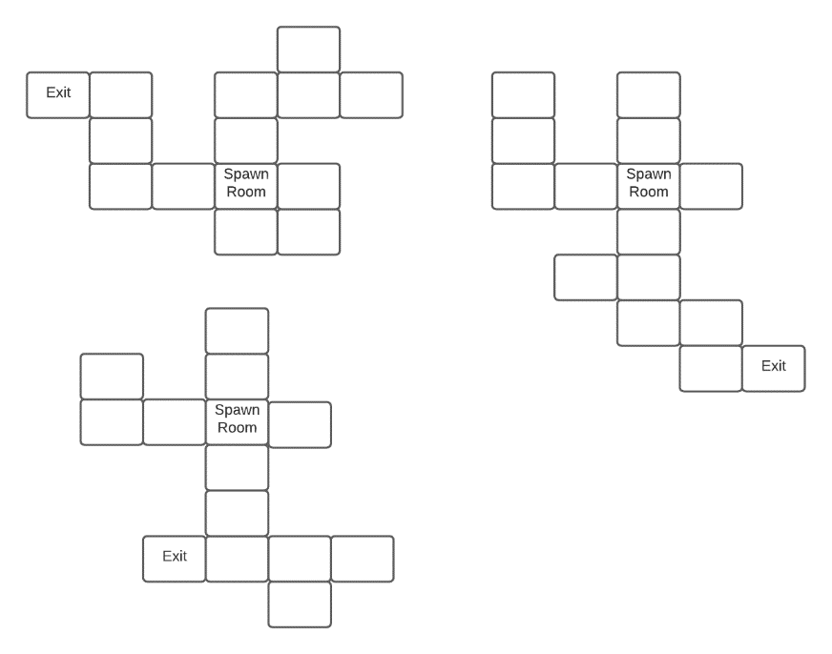
Figure 1:
This diagram showcases the different possible map combinations that can arise out of the random dungeon generation system that will be implemented.

Despite their differences, all potential dungeon maps share some similarities. This includes a spawn room where the player will first begin the game. This room will have 4 doors leading to other rooms in 4 possible directions.

Each map will also include an exit room which the player can enter to do battle with the final boss to escape the dungeon and win the game.
Figure 1: Three potential dungeon maps

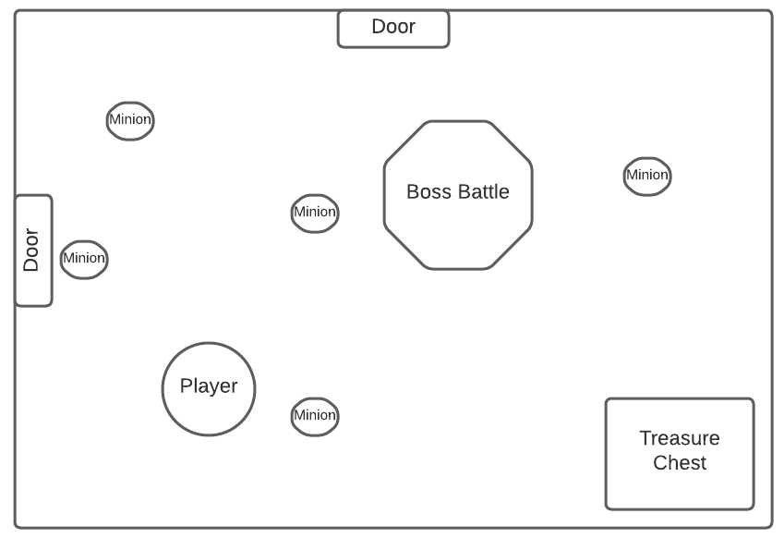
Figure 2:
In this diagram, we see a potential scene involving a player doing battle with one of the enemies in the dungeon. Some enemies may come with minions which are smaller versions of them and easier to defeat. Included in the diagram is also a treasure chest which is a rare item that once the enemies are defeated, can be unlocked to obtain several useful weapons or consumables.
Figure 2: A player battling and enemy

Implementation:
The game will require the use of several different game objects (classes) to accommodate all the desired features. Some of these classes include the player class, enemy class, loot class, a dungeon room spawner class, and a dungeon room template class.
The Player:
The player class will include a series of player-specific variables such as health, damage dealt, sanity levels and an array to account for the player’s inventory of items. The player object will also have a box collider associated with it to be used for event triggers and enemy battles. The player’s weapon is a sword, this sword can be swapped out for much better ones (higher damage dealt) as the player progresses through the game and defeats more enemies.
The player class also includes a checking method that is running constantly in the background while the game is still running. This check aims to ensure that the player’s health is above 0 and that their sanity level is about 30%. If the check comes back as false, the player is killed (sprite death animation is played) and then the player object is removed from the scene before triggered the game over title screen text.
The Enemy:
For the prototype of this game, I aim to create at least some variation with regards to the enemies, however, will first only focus on the implementation of two types of enemies.
- The Minion: These are smaller versions of the bigger enemy and are much easier to kill
- The Boss: This is the bigger enemy which does a lot more damage and is a lot harder to kill.
Both enemies will have a separate class of their own to store character-specific variables such as damage dealt, health, attack details, etc.
Both, however, will include the use of NPC AI to be able to detect the location of the player and move towards them to make an attack. This will be done using colliders within unity to measure how far away a player is from an enemy. If the player gets too close it triggers the follow method within the class and the enemy will now more towards the player’s location.
To generate enemies within the game scene, prefabs will be created using the enemy sprites. The number of enemies in a room will be randomly determined using the random range function to spawn any number of minions between 3 – 7 or boss enemies between 0 to 1. Upon death of the boss enemy and its minions, the enemy objects will be removed from the scene and will be replaced by in-game loot or consumables for the player to pick up.
The Loot:
This class will contain an array linked to all the loot prefabs. It will be used primarily by the enemy class to randomly pick which loot objects to give a player. Each loot type is given a weighting to determine whether it is common, uncommon, or rare. The rarer an item is the less likely it is to be dropped upon enemy death.

The Map Generation:
To achieve some degree of replay-ability, the use of random dungeon map generation will be used, hence, the need to create my own bespoke scripts.
All possible types of dungeon rooms (e.g., a room with only a door at the top or a room with a door at the top and the bottom) will first need to be created with game objects to signify the direction of the doors in the rooms. These door game objects will be used later in the code to determine how the rooms can be connected. These dungeon rooms will then all be converted into prefabs to be used within the dungeon room spawner class. This class will first generate the spawn room object for the player which will always be the same. It will then begin the process of linking other rooms to its doors.
An additional class will be created, a room template class to account for the different types of room templates. It will hold arrays for the four possible directions (top, bottom, right and left). The prefabs for room types will be then added to these arrays. This template class is then imported to the spawner class and will be used to generate a specific room to match the current room’s door locations. For example, if the room only has a right door, the spawner class will use randomly pick from within the template any of the room prefabs which can connect to a right door.

